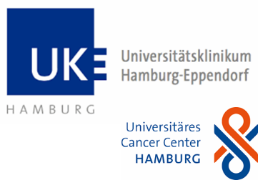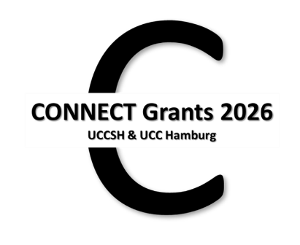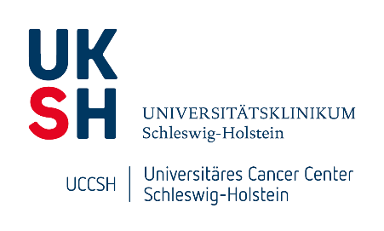

**Application form – CONNECT Grants 2026**

**Funding Period: January 1st until December 31st, 2026**

**Please complete this form for your CONNECT Grant application.**

Please submit the signed application and your CV as a **coherent PDF** by e-mail to ucch.science.info@uke.de.

**Submission Deadline:** **September 15th, 2025**

The application should be written in English, font Calibri 12 pt., and should not exceed **4 pages** excluding references.

# Study Project Title

***Please click here to type your project title.***

# Applicants [Team up with partners (teams from 2 to 4 researchers are eligible) from the respective other center (UCCSH or UCC Hamburg).]

## From UCCSH / UKSH

|  |  |  |  |  |  |
| --- | --- | --- | --- | --- | --- |
|  | Names (incl. titles) | E-mail-addresses | Positions | Affiliations (incl. City) | Dates of doctorates |
| 1 | ______ | ______ | ______ | ______ | ______ |
| 2 | ______ | ______ | ______ | ______ | ______ |

## From UCC Hamburg / UKE

|  |  |  |  |  |  |
| --- | --- | --- | --- | --- | --- |
|  | Names (incl. titles) | E-Mailaddresses | Positions | Affiliations | Dates of doctorates |
| 1 | ______ | ______ | ______ | ______ | ______ |
| 2 | ______ | ______ | ______ | ______ | ______ |

# Summary (max. 200 words)

***Please click here to write your summary.***

# Current State of Research in the Field/ Background

***Please click here to describe the current state of research.***

# Own Previous Work [Please indicate expertise and publications each partner brings into the tandem.]

***Please click here to describe your previous work.***

# Work Plan [Please outline the planned experiments including a specific timeline and contribution of each partner. For CS: please indicate research times and, if applicable, clinical release times as confirmed in the LoS by your department head for the project.]

***Please click here to describe your work plan.***

# Methodological Approaches [Please indicate the use of infrastructure, platforms, and technologies on the two campi or elsewhere.]

***Please click here to describe your methodological approaches.***

# Added Value/ Focus Area [Please refer to the respective focus area into which the proposal fits, explain the added value for our NORD consortium and future potential of your joint project.]

|  |  |
| --- | --- |
| UCCSH | UCC Hamburg |
| Biomarker/Minimal Residual Disease | Dissemination & Metastasis incl. Liquid Biopsy |
| Metastasis/Dissemination | Prostate Cancer |
| Inflammation and Cancer | GI & Immuno-Oncology |
| Immunotherapy/Tumor Immunology | Neuro-Oncology |
| Precision Oncology & Resistance to Therapy | Hematology & Cellular Therapy |
| Health Care Research | |

***Please click here to explain your added value.***

# Financial Plan (up to 50,000 €, divided equally between the partners according to purpose) [Detailed budget justification: personnel, consumables; distribution among the applicants.]

***Please click here to explain your financial plan.***

# References

***Please click here to add your references.***

# Appendices: [CVs and letters of support can be added as separate PDFs but must be included in the final application PDF file.]

## CVs of all applicants, including publications & third-party funding.

## Letters of support of both participating departments (Kiel/ Lübeck and Hamburg) by department heads, including confirmation of clinical release times if applicable.

**Contacts:**

UCC Hamburg: Dr. Natascha Kömm (n.koemm@uke.de) &   
Dr. Inga Melzer (i.melzer@uke.de)

UCCSH: Prof. Susanne Sebens (susanne.sebens@uksh.de),  
Prof. Timo Gemoll (timo.gemoll@uksh.de) &  
Dr. Sarah Habig (sarah.habig@uksh.de)